Table of Contents

Introduction 3
Project Structure 5
Controllers Overview 7
Models Overview 8
Database Setup 9
Caching Mechanism 9
Authorization and Authentication 10
Common Functions and Utilities 11
API Documentation 12
Deployment 13
Troubleshooting 14

Introduction

This documentation provides an overview of the traceability web application designed for FB production lines. The application ensures that the correct parts are used during the production of finished goods by integrating with a handheld scanner, a client application, and a Programmable Logic Controller (PLC) – which controls the signal lights.

The system is built on an ASP.NET web application (written in C#) deployed on a Windows IIS server (which is on a virtual machine), with a Microsoft SQL database backend. Users interact with the application by logging in and entering the finished good number they wish to produce. The application then retrieves and displays the required parts from the database. As each part is scanned using a handheld scanner, the data is sent through a client application to the web server for validation against the database. If the part is correct, the server sends a confirmation back to the client application, which then signals the PLC to indicate the correct part has been scanned by flashing a green light or red light in the case of wrong parts.

This system enhances production accuracy and efficiency by providing real-time validation and traceability of parts used in manufacturing, ensuring that the correct components are assembled for each finished product.

- Installation

### Prerequisites
- [.NET SDK](https://dotnet.microsoft.com/download)
- [SQL Server](https://www.microsoft.com/en-us/sql-server/sql-server-downloads) or another supported database system
- [Visual Studio](https://visualstudio.microsoft.com/) or any other IDE with .NET support

### Steps
1. Clone the repository:
```sh
git clone <repository-url>
```
2. Navigate to the project directory:
```sh
cd project-directory
```
3. Restore dependencies:
```sh
dotnet restore
```
4. Update the `appsettings.json` file with your database connection string.
5. Apply database migrations:
```sh
dotnet ef database update
```
6. Run the application:
```sh
dotnet run
```

Project Structure

WB
├── .vscode
├── logs
├── packages
├── WB
│ ├── .config
│ ├── Areas
│ │ └── Identity
│ │ └── Data
│ │ └── Pages
│ │ ├── Account
│ │ ├── _identityLayout.cshtml
│ │ ├── _identityLayout.cshtml.cs
│ │ └── _ValidationScriptsPartial.cshtml
│ │ └── _ViewImports.cshtml
│ │ └── _ViewStart.cshtml
│ ├── bin
│ ├── Connected Services
│ ├── Controllers
│ │ ├── CategoryController.cs
│ │ └── HomeController.cs
│ ├── Data
│ │ └── ApplicationDbContext.cs
│ ├── Migrations
│ │ └── ApplicationDb
│ │ ├── 20231102040521_poka_trace1.cs
│ │ ├── 20231102040521_poka_trace1.Designer.cs
│ │ └── ApplicationDbContextModelSnapshot.cs
│ ├── Models
│ │ ├── Category.cs
│ │ ├── ErrorViewModel.cs
│ │ ├── ScanLog.cs
│ │ ├── ScannerDTO.cs
│ │ ├── SearchLogViewModel.cs
│ │ └── state_change.cs
│ ├── obj
│ ├── Properties
│ ├── Views
│ │ ├── Category
│ │ │ ├── Create.cshtml
│ │ │ ├── DbError.cshtml
│ │ │ ├── Delete.cshtml
│ │ │ ├── DeleteLog.cshtml
│ │ │ ├── Edit.cshtml
│ │ │ ├── Index.cshtml
│ │ │ ├── List_Table.cshtml
│ │ │ ├── LogView.cshtml
│ │ │ ├── SelectedPN.cshtml
│ │ │ └── SelectedPNUpdate.cshtml
│ │ ├── Home
│ │ └── Shared
│ │ ├── _ViewImports.cshtml
│ │ └── _ViewStart.cshtml
│ ├── wwwroot
│ ├── appsettings.Development.json
│ ├── appsettings.json
│ ├── Program.cs
│ ├── scanner.cs
│ ├── ServiceExtensions.cs
│ ├── WB.csproj
│ ├── WB.csproj.user
│ ├── WB_Api
│ ├── Commands.txt
│ └── WB.sln

Sequence Diagram
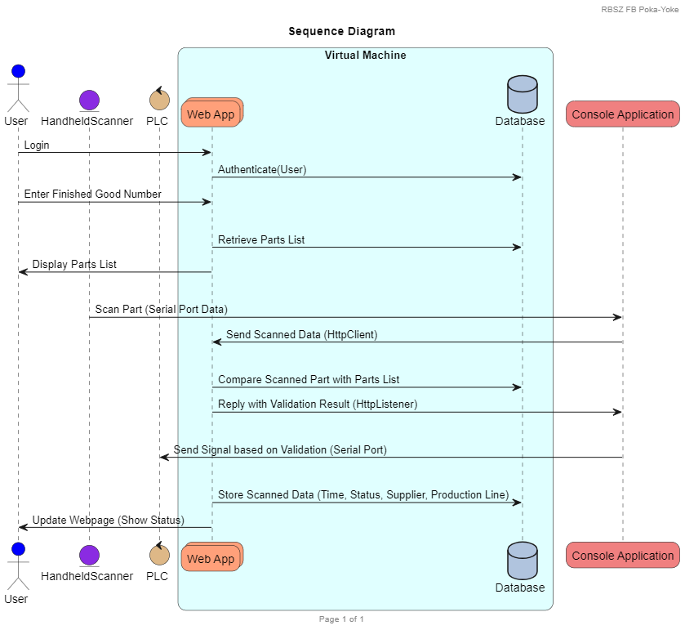

Controllers Overview

Controllers handle the incoming HTTP requests, process them, and return appropriate responses. They interact with the models to fetch or update data and use views to render the final HTML.

- **CategoryController**: Manages categories, including listing, creating, editing, and deleting categories.
- **LogController**: Handles logging and viewing of log entries.

- Views Overview

Views are responsible for rendering the user interface. They use Razor syntax to dynamically generate HTML content.

- **Category Views**: Located in `Views/Category`, these views manage the display and interaction with category data.
- **Log Views**: Located in `Views/Log`, these views handle the display of log entries.

Models Overview

Models represent the data structure and business logic of the application.

- **Category**: Represents a category entity with properties like `MaterialNumber` and `ComponentNumber`.
- **Log**: Represents log entries with properties like `MaterialNumber`, `Status`, `Supplier`, `Line`, `Date`, etc.

Database Setup

The application uses Entity Framework Core to manage database operations. The database context is defined in `ApplicationDbContext.cs`.

### Applying Migrations

To create or update the database schema, use the following commands:

```sh
dotnet ef migrations add <MigrationName>
dotnet ef database update
```

Caching Mechanism

Caching is used to store frequently accessed data temporarily to improve application performance. The cache is managed using in-memory caching provided by .NET.

Authorization and Authentication

Authorization and authentication are implemented using ASP.NET Core Identity. This provides mechanisms for user management, including registration, login, and role-based access control.

Common Functions and Utilities

### Sending Data to Client

Data is sent to the client via JSON responses in API controllers or by rendering views with data passed from the controller.

### Receiving Data from Client

Data is received from the client through form submissions or API requests. The data is validated and processed accordingly.

### Evaluating Data from Client

Client data is evaluated using model validation attributes and custom validation logic within controllers.

API Documentation

For API endpoints, detailed documentation is generated using Swagger. To view the API documentation, run the application and navigate to `/swagger`.

Deployment

### Steps
1. Publish the application:
```sh
dotnet publish -c Release -o ./publish
```
2. Deploy the contents of the `./publish` directory to your server.
3. Configure your server to run the application. For IIS, use the [ASP.NET Core Module](https://docs.microsoft.com/en-us/aspnet/core/host-and-deploy/iis/?view=aspnetcore-6.0).

Troubleshooting

### Common Issues
- **Database Connection Issues**: Ensure the connection string in `appsettings.json` is correct.
- **Migrations Not Applied**: Run `dotnet ef database update` to apply pending migrations.
- **Caching Issues**: Clear the cache if outdated data is being displayed.

---

This streamlined documentation should provide a comprehensive overview of the project without delving into the specific details of each controller. Let me know if there's anything else you need!

